1. Consider the Cats & Dogs example. Start initially with a training sample of 1000, a  
   validation sample of 500, and a test sample of 500 (like in the text). Use any technique  
   to reduce overfitting and improve performance in developing a network that you train  
   from scratch. What performance did you achieve?

**Loading the Dataset:**

An empty DataFrame named 'train' is created to store the training dataset.

The image data and corresponding labels are loaded from the 'TRAIN_DIR' directory using a function called 'load_dataset.' This function reads image files, processes them, and assigns labels (e.g., 0 for cats and 1 for dogs) to each image. The image data and labels are stored in the 'train' DataFrame.

The 'train' DataFrame is shuffled to randomize the order of the data. Shuffling helps prevent any biases that could be introduced if the data had a specific order. The 'sample' function is used to achieve this, and the index is reset to start from 0 in a continuous manner.

The code concludes by displaying the first few rows of the 'train' DataFrame to allow for an initial inspection of the dataset's structure.

Similarly we load the dataset for Testing and Validation.

**Creating a Plot for the dataset**:

This code segment focuses on exploring and visualizing the training, testing, and validation dataset. It displays a count plot of labels to understand the distribution of different classes (cats and dogs) in the dataset. The total number of images in the training dataset is also calculated and printed for reference. This initial data exploration helps provide insights into the composition of the training dataset and can be valuable when designing and training a machine learning model

**Displaying the images on the grid:**

1. **Importing Libraries:**
   * The code starts by importing the necessary libraries, including Keras for image loading and Matplotlib for image visualization.
2. **Creating a Figure for Image Display:**
   * A Matplotlib figure is created with a size of 20x20 inches to prepare a canvas for displaying multiple images in a grid.
3. **Selecting a Subset of Training Data:**
   * A subset of the training dataset is selected for display. In this case, the first 25 rows (images) of the 'train' DataFrame are chosen. These 25 images will be shown in a 5x5 grid.
4. **Iterating and Displaying Images:**
   * A loop iterates through the selected subset of images (25 images in this case). For each image, the loop extracts the file path (file) and the corresponding label from the 'train' DataFrame.
   * A subplot within the 5x5 grid is created using Matplotlib's subplot function. The index+1 argument specifies the position of the subplot within the grid.
   * The image is loaded using Keras's load_img function, converted to a NumPy array, and stored in the 'img' variable.
   * The image is displayed using plt.imshow to show the visual representation of the image, and the title of the subplot is set to the image's label using plt.title(label).
   * plt.axis('off') is used to turn off the axis labels and ticks, providing a cleaner display.
5. **Displaying the Grid of Images:**
   * After iterating through all 25 images, the code displays the entire grid of images within the previously created Matplotlib figure.

**Performing Data Preprocessing and Augmentation for the training dataset:**

1. **Importing Libraries:**
   * The code begins by importing the necessary library, which is Keras' ImageDataGenerator for data augmentation and preprocessing.
2. **Data Preprocessing with ImageDataGenerator:**
   * An ImageDataGenerator object named 'train_datagen' is created to preprocess the training data.
   * The following data augmentation techniques are applied:
     + rescale=1./255: This rescales the pixel values of the images to the range [0, 1], which is a common practice to standardize the data.
     + shear_range=0.2: Shearing is applied to the images, which involves shifting parts of the image in a fixed direction. This helps introduce variability to the dataset.
     + zoom_range=0.2: Random zooming is applied to the images, providing variations in the scale of objects in the images.
     + horizontal_flip=True: Horizontal flipping is performed, which creates mirror images of the original images, further enhancing data variability.
3. **Creating the Data Generator:**
   * The code then creates a data generator for the training set using the ImageDataGenerator. This data generator is named 'training_set'.
   * The flow_from_dataframe function is used to specify how the data should be loaded from the 'train' DataFrame.
   * dataframe=train: The 'train' DataFrame is specified as the source of data.
   * x_col='image': The 'image' column in the DataFrame is used to load the image data.
   * y_col='label': The 'label' column is used to load the corresponding labels.
   * target_size=(224, 224): The target size for the images is set to (224, 224), meaning that all images will be resized to this size during preprocessing.
   * batch_size=Batch_size: The batch size for training is set to the previously defined 'Batch_size.'
   * class_mode='categorical': The class mode is specified as 'categorical,' indicating that the labels are in one-hot encoded format.

Simlarly we do the data preprocessing for training and validation dataset.

**Convolutional neural network (CNN) model using the Keras library for image classification:**

1. **Model Initialization:**
   * model = Sequential(): This line creates a sequential model, which is a linear stack of layers. Sequential models are commonly used for building CNNs and other deep learning architectures.
2. **Adding Convolutional Layers:**
   * model.add(Conv2D(32, (3, 3), activation='relu', input_shape=(224, 224, 3)): This line adds the first convolutional layer to the model.
     + 32 is the number of filters (or kernels) in the layer. Each filter detects specific features in the input data.
     + (3, 3) defines the size of the convolutional kernel, in this case, a 3x3 kernel.
     + activation='relu' specifies the Rectified Linear Unit (ReLU) activation function, which introduces non-linearity to the model.
     + input_shape=(224, 224, 3) defines the input shape for the first layer. It expects images with dimensions of 224x224 pixels and three color channels (RGB).
   * model.add(MaxPooling2D((2, 2)): After the first convolutional layer, a max-pooling layer is added.
     + Max-pooling reduces the spatial dimensions of the feature maps produced by the previous layer. In this case, it uses a 2x2 pooling window.
   * The code then adds another pair of convolutional and max-pooling layers with similar configurations.
3. **Flatten Layer:**
   * model.add(Flatten(): A flatten layer is introduced after the convolutional layers.
     + The flatten layer transforms the multi-dimensional feature maps into a one-dimensional vector, which is required before connecting to fully connected layers.
4. **Fully Connected Layers:**
   * model.add(Dense(64, activation='relu'): A dense (fully connected) layer with 64 units and ReLU activation is added.
     + Dense layers learn to classify features extracted by the convolutional layers.
   * model.add(Dense(2, activation='sigmoid'): Another dense layer with 2 output units (assuming binary classification) and sigmoid activation is added.
     + The sigmoid activation is commonly used for binary classification problems to produce class probabilities.

**Convolutional neural network (CNN) model for image classification using Keras (contd**):

1. **Model Architecture Definition:**
   * model_1 = Sequential([...]): This line defines a sequential model named 'model_1.' The model consists of a sequence of layers defined within the square brackets.
2. **Convolutional Layers:**
   * Several convolutional layers are defined to extract features from input images:
     + The first convolutional layer has 16 filters, a 3x3 kernel size, and ReLU activation. It expects input images of size (224, 224, 3) in RGB format.
     + The second convolutional layer has 32 filters, a 3x3 kernel size, and ReLU activation.
     + The third convolutional layer has 32 filters, a 3x3 kernel size, and ReLU activation.
     + The fourth convolutional layer has 64 filters, a 3x3 kernel size, and ReLU activation.
3. **Max-Pooling Layers:**
   * Max-pooling layers are inserted to downsample the feature maps:
     + After the first convolutional layer, a max-pooling layer with a 2x2 pooling window is added.
     + After the second pair of convolutional layers, another max-pooling layer with a 2x2 pooling window is added.
4. **Flatten Layer:**
   * A flatten layer is included to transform the multi-dimensional feature maps into a one-dimensional vector.
5. **Fully Connected Layers:**
   * A dense (fully connected) layer with 2 output units and sigmoid activation is added. This layer is used for binary classification, and it outputs class probabilities.
6. **Model Compilation:**
   * model_1.compile(...) is used to compile the model. The following settings are specified:
     + Loss function: Categorical cross-entropy ('categorical_crossentropy') is used as the loss function, suitable for multi-class classification.
     + Optimizer: 'Adam' is chosen as the optimization algorithm, which is a popular choice for gradient-based optimization.
     + Metrics: 'accuracy' is used as the evaluation metric to monitor the model's performance during training.
7. **Model Training:**
   * The model is trained using the training dataset ('training_set') with the following settings:
     + Number of epochs: Training is performed for 5 epochs (you can adjust this as needed).
     + Steps per epoch: The number of steps per epoch is set to the length of the training set. This ensures that the entire training dataset is used in each epoch.
     + Validation data: The model's performance is evaluated on a validation dataset ('validation_set').
     + Validation steps: The number of steps for validation is set to the length of the validation set.

**CNN model with convolutional layers, max-pooling layers, and fully connected layers for image classification**

1. **Model Architecture Definition:**
   * A sequential model named 'model_1' is defined with a sequence of layers:
     + The first layer is a convolutional layer with 16 filters, a 3x3 kernel size, and ReLU activation. It expects input images of size (224, 224, 3) in RGB format.
     + The second layer is another convolutional layer with 32 filters, a 3x3 kernel size, and ReLU activation.
     + A max-pooling layer follows with a 2x2 pooling window and 'valid' padding.
     + Two additional convolutional layers follow with 32 and 64 filters, both using 3x3 kernels and ReLU activation.
     + Another max-pooling layer follows with a 2x2 pooling window.
     + A flatten layer is included to transform the multi-dimensional feature maps into a one-dimensional vector.
     + The final layer is a dense (fully connected) layer with 2 output units and sigmoid activation, suitable for binary classification.
2. **Model Compilation:**
   * model_1.compile(...) is used to compile the model. The following settings are specified:
     + Loss function: Categorical cross-entropy ('categorical_crossentropy') is chosen as the loss function, typically used for multi-class classification tasks.
     + Optimizer: 'Adam' is selected as the optimization algorithm, which is a popular choice for gradient-based optimization.
     + Metrics: 'accuracy' is used as the evaluation metric to monitor the model's performance during training.
3. **Model Training:**
   * The model is trained using the training dataset ('training_set') with the following settings:
     + Number of epochs: Training is performed for 10 epochs (you can adjust this as needed).
     + Steps per epoch: The number of steps per epoch is set to the length of the training set. This ensures that the entire training dataset is used in each epoch.
     + Validation data: The model's performance is evaluated on a validation dataset ('validation_set').
     + Validation steps: The number of steps for validation is set to the length of the validation set.

**Model Evaluation:**

* model_1: This is the CNN model that was defined, compiled, and trained previously.
* .evaluate(testing_set): This method is called on the model to assess its performance. It takes the testing dataset (testing_set) as input for evaluation



Accuracy Graph:

1. **Extracting Training History:**
   * The code first extracts the training history information from the history_1 object, which typically contains metrics recorded during the model training process. Specifically, it retrieves training accuracy, validation accuracy, training loss, and validation loss.
2. **Creating Accuracy Graph:**
   * A plot is created for accuracy. It plots the training accuracy (in blue) and validation accuracy (in red) over the number of epochs.
   * The x-axis represents the number of training epochs, and the y-axis represents accuracy percentages.
   * A title 'Accuracy Graph' is added to the plot.
   * A legend is included to differentiate the training and validation accuracy curves.
3. **Creating Loss Graph:**
   * A separate plot is created for loss. It plots the training loss (in blue) and validation loss (in red) over the number of epochs.
   * The x-axis represents the number of training epochs, and the y-axis represents the loss values.
   * A title 'Loss Graph' is added to the plot.
   * A legend is included to differentiate the training and validation loss curves.
4. **Displaying Graphs:**
   * The plt.show() function is used to display both the accuracy and loss graphs.

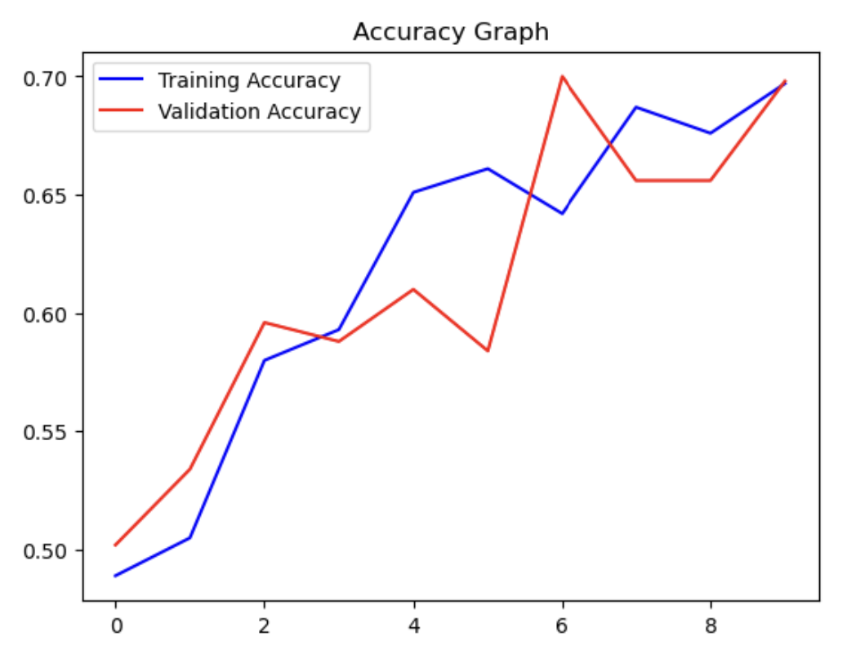 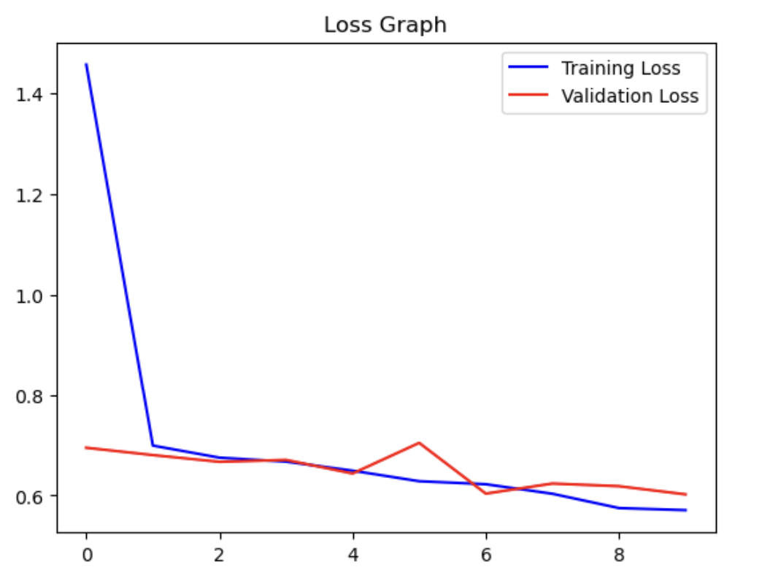

2. Increase your training sample size. You may pick any amount. Keep the validation and test samples the same as above. Optimize your network (again training from scratch). What performance did you achieve?

Here the training dataset has been increased to 3000 inorder to train the data to get the better results with accuracy of the model.

1. **Importing Libraries:**
   * The code starts by importing the necessary libraries, including Pandas for data manipulation, Seaborn for data visualization, and Matplotlib for creating plots.
2. **Creating a Training DataFrame (train_v2):**
   * A Pandas DataFrame named 'train_v2' is created to store the training dataset.
   * The code attempts to load image data and their corresponding labels from a directory specified in 'TRAIN_V2_DIR' using the 'load_dataset' function.
   * The 'load_dataset' function is expected to read image files, process them, and assign labels to each image.
3. **Shuffling the Dataset:**
   * The 'train_v2' DataFrame is shuffled to randomize the order of the data. This helps avoid any biases that might be introduced by a specific order of data. Shuffling is performed using the 'sample' function with 'frac=1' to retain all data and reset the index.
4. **Creating a Count Plot of Labels:**
   * A count plot of the labels in the 'train_v2' DataFrame is generated using Seaborn. The 'countplot' function is used to visualize the distribution of labels in the training dataset.
   * The plot is displayed within a figure of size 10x6, with a title ('Label Count Plot') for clarity.
   * The x-axis is labeled as 'Label,' and the y-axis is labeled as 'Count.'
5. **Printing Total Image Count:**
   * The code calculates and prints the total number of images in the 'train_v2' dataset. This count is determined by finding the length of the 'train_v2' DataFrame.
6. **Displaying the Plot:**
   * Finally, the plot is shown using 'plt.show()'.

We repeat the same steps using the above question for Model classification Using Convolutional Neural Network(CNN)

Performance achieved from the new Dataset:



**Accuracy Graph:**

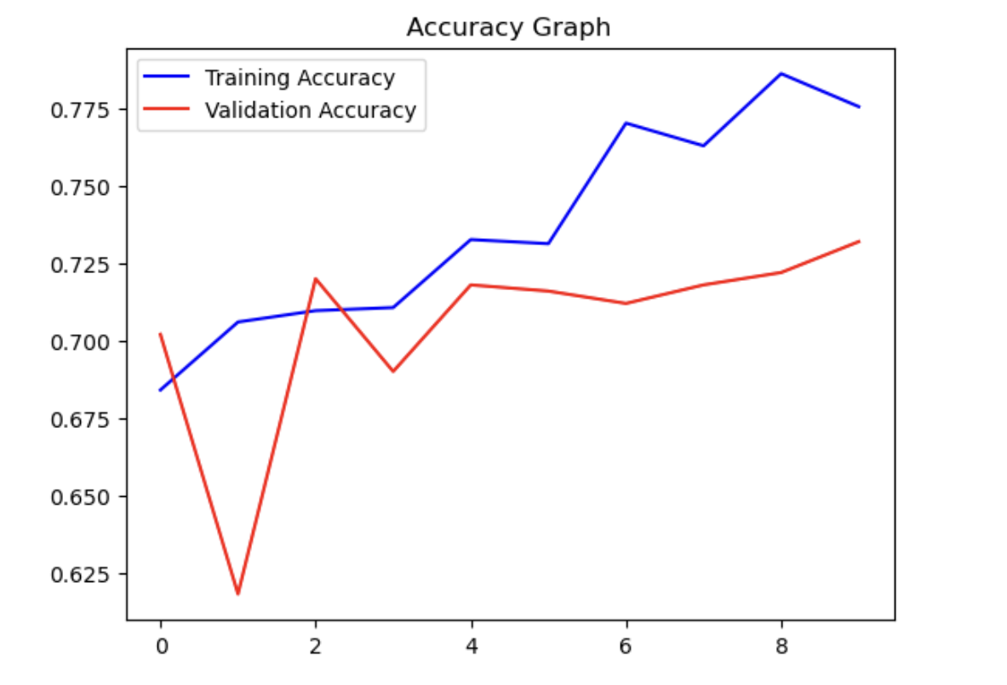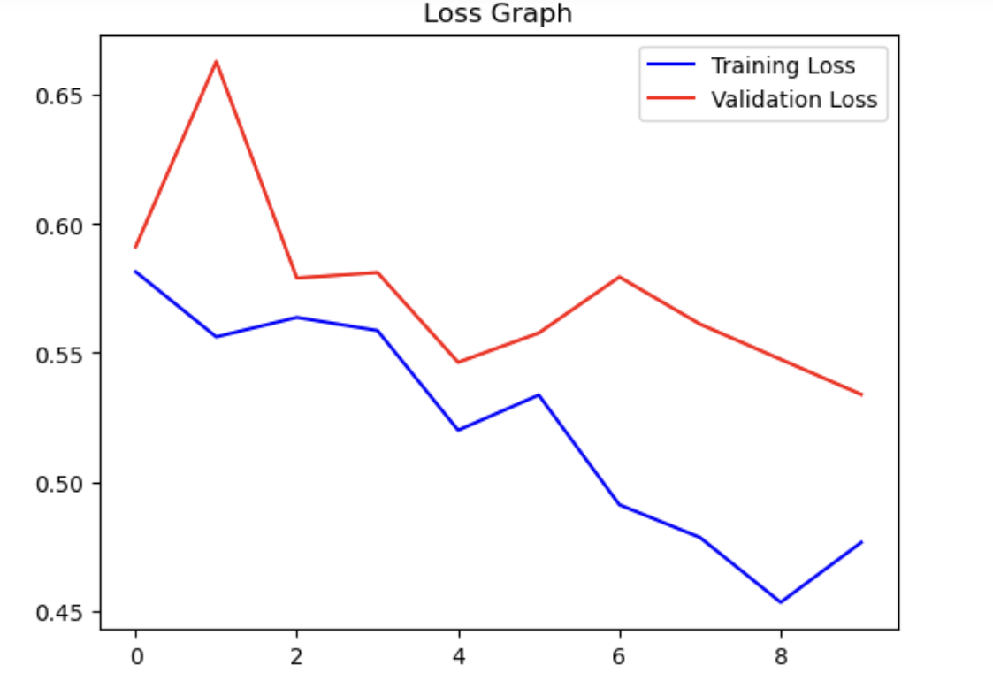

3. Now change your training sample so that you achieve better performance than those from Steps 1 and 2. This sample size may be larger, or smaller than those in the previous steps. The objective is to find the ideal training sample size to get best prediction results.

Based on the 1st and 2nd question it could be inferred that with increase in dataset the model accuracy could be improved.

The dataset is now increased to 6000 images in training and it is trained by using the above steps, after training the data with 6000 images it is identified that the accuracy has improved a bit.

The results for the same can be seen below:

**Model Evaluation:**

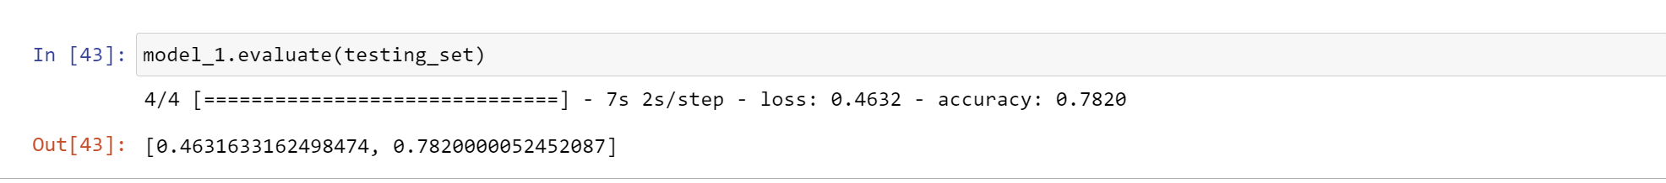

**Accuracy of the Graph:**

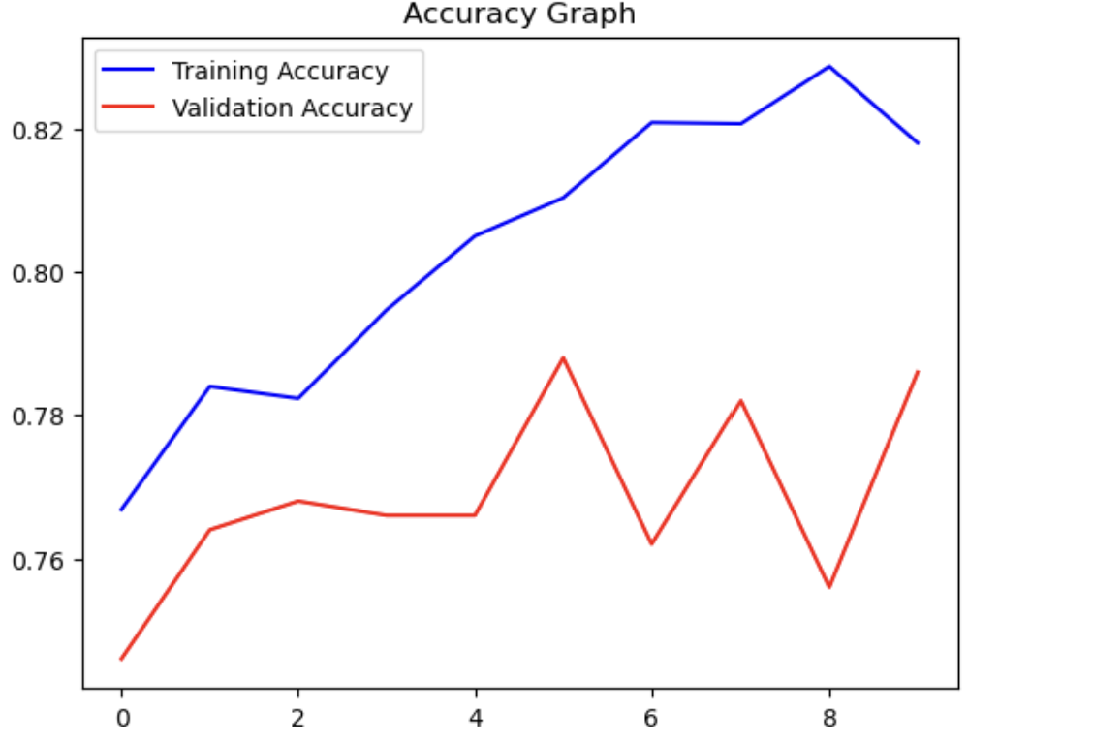 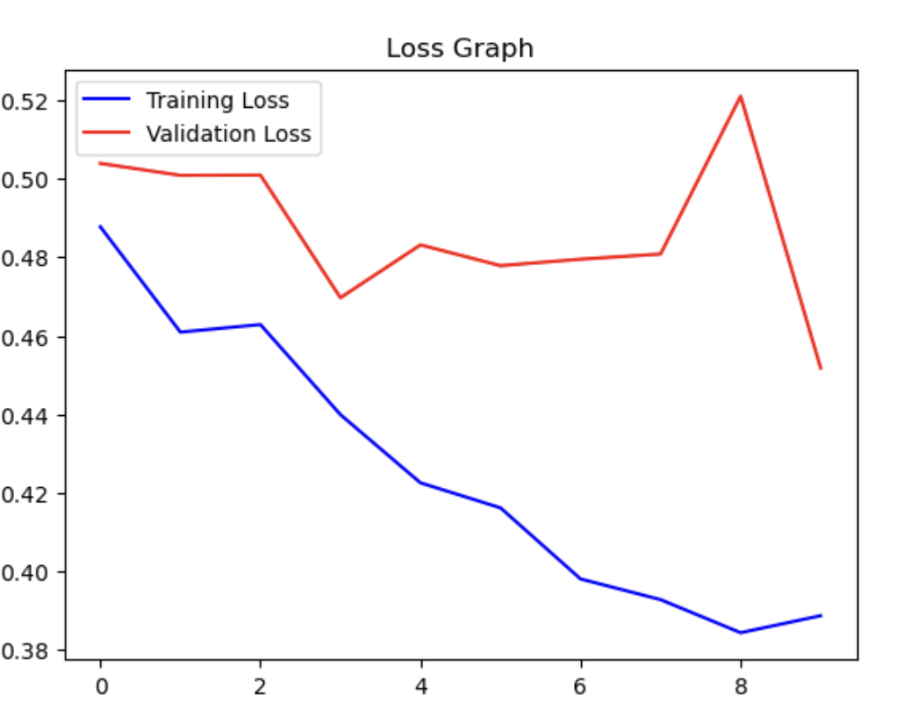

4. Repeat Steps 1-3, but now using a pretrained network. The sample sizes you use in Steps 2 and 3 for the pretrained network may be the same or different from those using the network where you trained from scratch. Again, use any and all optimization techniques to get best performance

**VGG16** is the pretrained model used here to train the dataset.

**CNN built on top of the pre-trained VGG16 architecture**:

1. **Base Model (VGG16):**
   * The base_model is created using the VGG16 architecture pre-trained on the ImageNet dataset.
   * weights='imagenet' indicates that the model's initial weights are loaded from pre-trained weights on ImageNet.
   * include_top=False means that the top (fully connected) layers of the VGG16 model are not included. This allows for building custom fully connected layers for a specific classification task.
   * input_shape=(img_size[0], img_size[1], 3) defines the expected input shape for the model, with height and width specified by img_size and 3 channels (for RGB images).
2. **New Model (model_pre) on Top of VGG16:**
   * A new sequential model, model_pre, is created to build custom layers on top of the VGG16 base model.
3. **Flatten Layer:**
   * A flatten layer is added to transform the multi-dimensional feature maps produced by the VGG16 base model into a one-dimensional vector.
4. **Dense Layers:**
   * Two dense (fully connected) layers are added:
     + The first dense layer consists of 512 units and uses the ReLU activation function ('relu').
     + A dropout layer with a dropout rate of 0.5 is added after the first dense layer. Dropout helps prevent overfitting.
     + The final dense layer consists of 2 units with a sigmoid activation. This indicates that the model is designed for binary classification.
5. **Model Compilation:**
   * The model_pre is compiled with the following settings:
     + Optimizer: Adam with a learning rate of 0.0001 is used for gradient-based optimization.
     + Loss function: Categorical cross-entropy ('categorical_crossentropy') is selected for multi-class classification problems.
     + Metrics: 'accuracy' is chosen as the evaluation metric to monitor the model's performance during training.

**CNN model on the training dataset for 10 epochs while validating its performance on a separate validation dataset**

model_pre.fit(...): This method is used to train the CNN model (model_pre) with the specified training and validation datasets. It performs the following tasks:

* training_v3_set: This is the training dataset provided for model training.
* steps_per_epoch=len(training_v3_set): The number of steps (batches) per training epoch is set to the length of the training dataset. This ensures that the entire training dataset is used in each epoch.
* epochs=10: The model is trained for 10 epochs. An epoch is a complete pass through the entire training dataset.
* validation_data=validation_set: The model's performance is evaluated on the validation dataset (validation_set) after each epoch. This allows monitoring how well the model generalizes to new, unseen data.
* validation_steps=len(validation_set): The number of steps (batches) for validation is set to the length of the validation dataset

**Evaluation of the model based on the Training dataset:**

* model_pre.evaluate(testing_set): This line of code invokes the evaluate method on the model_pre model to assess its performance on the testing dataset. The evaluation process involves the following steps:
  + testing_set: This is the testing dataset provided for evaluation. It contains a set of data examples and their corresponding labels.
  + The model processes the data in the testing dataset and computes its performance metrics, such as accuracy and loss, on this dataset.
* The evaluation results are typically returned as a tuple of values, which may include accuracy, loss, and other metrics specified during model compilation. These results can be used to assess how well the model generalizes to unseen data and to make informed decisions about its performance.

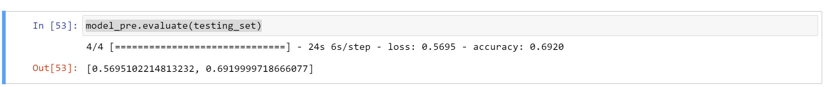

**Performance representation of a trained neural network model by plotting and displaying two key metrics: accuracy and loss**.

1. **Extracting Training History:**
   * The code first extracts the training history information from the history_pre object, which typically contains metrics recorded during the model training process. Specifically, it retrieves training accuracy, validation accuracy, training loss, and validation loss.
2. **Creating Accuracy Graph:**
   * A plot is created to visualize accuracy. It plots the training accuracy (in blue) and validation accuracy (in red) over the number of epochs.
   * The x-axis represents the number of training epochs, and the y-axis represents accuracy percentages.
   * A title 'Accuracy Graph' is added to the plot.
   * A legend is included to differentiate the training and validation accuracy curves.
3. **Creating Loss Graph:**
   * A separate plot is created to visualize loss. It plots the training loss (in blue) and validation loss (in red) over the number of epochs.
   * The x-axis represents the number of training epochs, and the y-axis represents the loss values.
   * A title 'Loss Graph' is added to the plot.
   * A legend is included to differentiate the training and validation loss curves.
4. **Displaying Graphs:**
   * The plt.show() function is used to display both the accuracy and loss graphs.

**SUMMARY:**

Training a Convolutional Neural Network (CNN) with larger datasets or more images can lead to improved results by addressing several key aspects of deep learning:

1. **Increased Diversity and Variability:**
   * Larger datasets typically contain a more diverse set of examples, covering a wider range of variations in the data. This diversity can help the model generalize better to unseen examples.
   * With more images, the model encounters a variety of lighting conditions, backgrounds, poses, and object orientations. This exposure to diverse scenarios helps the model become more robust.
2. **Reduced Overfitting:**
   * Overfitting occurs when a model becomes too specialized in fitting the training data, resulting in poor generalization to new data. Larger datasets help mitigate overfitting by exposing the model to a broader set of examples.
   * With more data, the model is less likely to memorize specific training examples and is more likely to learn meaningful patterns and features.
3. **Improved Feature Learning:**
   * CNNs learn hierarchical features from data. More data allows the model to refine its feature representations, recognizing subtle patterns that might not be apparent with smaller datasets.
   * Deeper and more abstract features can be learned with larger datasets, enabling the model to capture more complex relationships within the data.
4. **Better Optimization:**
   * Optimization techniques, such as gradient descent, benefit from larger datasets. More data provides a smoother and more accurate estimate of the true underlying data distribution, which facilitates optimization.
   * Gradient updates tend to be more stable with larger datasets, making it easier for the model to converge to a good solution.

Optimization Techniques for Training CNNs with Large Datasets:

1. **Batch Normalization:**
   * Batch normalization helps stabilize training by normalizing activations within each mini-batch. It can accelerate training and improve model generalization.
2. **Learning Rate Scheduling:**
   * Adaptive learning rate schedules, such as learning rate decay, can help the model converge effectively. With larger datasets, a learning rate schedule can be more crucial.
3. **Data Augmentation:**
   * Data augmentation artificially increases the dataset's size by applying random transformations to training images (e.g., rotations, flips, crops). This technique helps the model generalize better, especially when the dataset is large.
4. **Regularization:**
   * Techniques like dropout and L2 regularization help prevent overfitting even when using large datasets. They encourage the model to learn robust and generalizable features.
5. **Ensemble Learning:**
   * Training multiple CNN models and combining their predictions can enhance performance. This technique, known as ensemble learning, leverages the diversity of multiple models.
6. **Transfer Learning:**
   * Transfer learning involves using pre-trained models (e.g., ImageNet) as a starting point. These models have learned rich feature representations on large datasets. Fine-tuning a pre-trained model on your specific dataset can lead to excellent results.